FYS4260/FYS9260 2021:

Mandatory lab project task:

Target specifications for my lab project

|  |  |
| --- | --- |
| **Student Name:** | Emiliano Staffoli |
| **Lab project name:** | Digital Clock using IC4026 |
| **Specification version/date:** |  |

1. Use case description:

Describe briefly in plain words how you will use/operate your circuit in your targeted use situation. Include:

* How you will connect power and activate the circuit
* How you use any buttons or indicators
* How you will package (or could package) the circuit board
* Other central features, such as frequency adjustment?

|  |
| --- |
| **Use case (scenario) description** |
| *My purpose is to make a digital clock displaying the time in a 24h format, showing current seconds, minutes and hours. The circuit will be powered through a 5V source provided by a USB charger, so that it can easily be used in a closed space. When the charger will be plugged in, the circuit will start operating, so there’s no need for general switches to turn it on. The current time will be provided through 6 7-segment displays positioned in the above part of the circuit. Two 7-segment displays will be used for the display of the seconds and they will be positioned very close between each other, the same is valid for the couples of 7-segment displays showing respectively the minutes and hours counts. A little space will be left between each couple of 7-segment displays in order to provide more readability for the user. The bottom part of the TOP level of the PCB will host two pushbuttons to adjust respectively the hour count and the minute count. Each pushbutton will be located exactly below the corresponding couple of 7-segment displays, in order to provide a more intuitive adjusting to the user. The power input will be located on one of the sides of the board, so that it can be hung to a wall.* |

# 2. Specifications:

Complete a specification table as outlined below:

|  |  |  |  |
| --- | --- | --- | --- |
| **Functionality** | **Target specification** | **How you will verify that you have reached your target** | **Verification result** |
| Packaging: wall fixing | Ø4mm holes for wall fixing | Inspection |  |
| Packaging: displays | 6 7-segment displays on the above part of the PCB displaying seconds, minutes and hours | Inspection |  |
| Packaging: pushbuttons | Locate pushbuttons for hour and minute adjustment right below the corresponding couple of 7-segment displays. | Inspection |  |
| Power: input pin | Locate the input pin for the power line on the side of the PCB. | Inspection |  |
| Power | 5V DC provided by a USB charger | Demonstration: connecting the cable to the circuit, it will start working. | I didn’t write anything about power consumption expectations since we do not really care about them, since this clock is not going to be powered with a cable and not with a battery. |
| Power ON/OFF | The circuit starts working when the cable is plugged in | Demonstration: plug in the cable and the time starts being displayed (from 00:00:00) |  |
| Anti-bouncing system | Avoid multiple steps while adjusting time through pushbuttons. | Testing: adjust the time by pressing the buttons and verify that each push leads to a single step forward of the counter. |  |
| Time regulation | In correspondence of critical hours (e.g. transition between 23:59:59 and 00:00:00), correct transitions occurs, both if naturally occurring or user stimulated. | Demonstration: |  |
| Reliability | 24h operating without failures | Testing: plug in the power cable and verify the correct functioning for 24h | Initially the intention was to test the clock for 10 days to check for possible failures after some time of operation. However, the professor told me that it is not necessary, simpler test are enough. I reduced the time to 24h. In the report I’ll specify that long-time test would be required for industrial products, but it's not our case. |
| Accuracy: constant temperature | The clock loses less than a second per hour when it is kept in a steady-temperature room (*) | Testing: check the discrepancies with a standard clock in 1h, 6h, 12h after powering up (multiple trials) | In the report, write that you could have used an oscillator as IC for generating the 1Hz clock, but with the 7555 is more interesting.  About the precision, I also checked the possible influence coming from the intrinsic delay of the ICs that we are using. It is on the order of hundreds of ns, which much smaller than any possible influence coming from a wrong capacity/resistance that enters in the generation of the 1Hz signal.  UPDATE: probably such a test is not mandatory due to the fact that I cannot perform it with the correct measurement system in the lab. I’ll probably do it at home, so it won’t be reliable. |
| Accuracy: temperature dependence  THIS TEST HAS BEEN DELETED | Temperature won’t affect sensibly the precision of the clock | Testing: check the discrepancies with a standard clock in 1h, 6h, 12h after powering up at different temperatures (between 15°C and 25°C) | The temperature in my opinion won’t affect the behaviour of the clock, since on the resistors datasheet I found that their value changes as a few ppm/K, so the results of a change in the temperature will be visible just after a long time.  UPDATE: this test will be difficult to be performed in the lab. Since I have not enough time and such a test is not even required, I’ll write that I would have done it, but it’s behind the scope of the course. |
| 1Hz signal source | Main contribution to the uncertainty is given by the capacitor | Testing: through an oscilloscope assess the frequency of signal generated by the IC7555 | I think that this will be the biggest source of errors: the frequency of the signal depends on two resistors and a capacitor and the uncertainty on the capacitor is very high (20% of nominal value). The uncertainty on the frequency will be approximately around 20% of its nominal value and this is obviously not acceptable for a clock! So we’ll try to verify the frequency of the signal coming out from the 7555, or we could measure the capacitor before mounting it! The uncertainty on the resistors is on the order of 1%, so their contribution to the uncertainty on the frequency is much lower! In case the frequency will be very bad, I could write in the report that using a quartz oscillator instead of an IC7555 would be synonym of much higher accuracy and precision. |
| Essential components | List | -IC7555: 1Hz clock signal generator  -IC4026: counters and -7-segment display drivers  -Push buttons: employed to set hours and minutes  -74AHCT1G08 AND gates  -ACSA56-41 7-segment displays  -Resistors  -Capacitors  -Diodes |  |

*(*) assuming the uncertainty on the capacity connected to the IC7555 to be null.*

*As a minimum, you should specify*

* *Power supply/power requirements in order to operate circuit*
* *Important components, for example sensor components or specific*
* *User interface features, for example buttons, screens (what should it display?)*
* *Radio features – if relevant – frequencies range and so forth*
* *Packaging requirements – if you plan to place the circuit in a box for example*

*Explanation:*

*The target specification should be clear and understandable. It should not be difficult to determine whether you have met your target after you have realized your circuit.*

*Outline how you can verify that you have met the different requirements. Ideally, after the circuit have been realized, it should be possible to write just a short explanation once the circuit has been tested. You can consider verification either by means of 1) inspection (e.g. circuit board has screw holes for attachment), 2) demonstration (e.g. transmission frequency is given in the display) or 3) testing (e.g. test how far apart two ISM radios can be and still communicate with each other)*

*The final column, Verification result, can be left without text now. In your final project report, you are expected to include the list of target specifications you have defined, and also describe the verification testing results.*

*The targets you define should be realistic and reflect the needs in your application. If you want to measure the temperature in your car from your home, you might need a radio with > 50 m range, and should specify this. It is however unlikely that you will achieve this in this lab project, but you should anyway plan a test to get an impression of how far you actually can communicate.*

*And if you later realize that there is a need to change the target requirements during the development process? Often, you will generate more insight as you work on a problem. It is therefore possible to change your mind - and your specifications - during the lab project, but in case, you should then be able to explain WHY you did the changes.*

# 3. Physical realisation:

Make a brief, simple sketch of the physical layout you envision. No details are expected, but try to think forward about where key components on the board should be located in order to work well in your applications. Some of the features you should think of early are connectors, control buttons, user interfaces (for example LEDs or LCD screens). Example given in appendix.

# Appendix:

***1. Example use case description:***

*My current thermometer is located outside a window where the morning temperature is often incorrect due to direct sun light. I aim to develop a wireless weather station to get a more realistic measurement point and also add humidity sensing. The solution will consist of two PCBs: One outdoor sensor PCB with ISM radio and a combined humidity+temperature sensor. One indoor sensor and display PCB with ISM radio,a temperature sensor, and a digital display where it is possible to toggle between indoor and outdoor readings. Both PCBs will be connected to 9VDC batteries, and both PCBs should instantly start working when connected to Power (no switch or button needed). Both PCBs will have screw holes to allow it to be screw attached. The outdoor PCB will be sealed from the outdoor environment by placing the circuit and the battery in a zip-lock plastic bag. The outdoor PCB will be placed in the back yard of my apartment, and the indoor PCB will be placed in the kitchen. The distance between the sensors will be approximately 10 meters with no significant obstructions in-between (just a window or a thin wooden wall). The indoor PCB will have a button to start up back-lighting of the display, and one button to toggle between 1) indoor temperature, 2) outdoor temperature, and 3) outdoor humidity. In addition to the sensor readings, the display will also display as text what reading (of the three) is given, and correct units (deg C and %relative humidity).*

***2. Example of specification (ISM transceiver):***

|  |  |  |  |
| --- | --- | --- | --- |
| **Functionality** | **Target specification** | **How you will verify that you have reached your target** | **Verification result** |
| Radio band used | ISM 866MHz | Inspection of radio chip |  |
| Radio range | At least 10 m in air from outdoor to indoor unit | Experimental testing |  |
| Sensor functionality | Outdoor unit:  Temperature sensor (thermistor)  Humidity sensor  Indoor unit:  Temperature sensor | Demonstration: Should indicate correct temperature, and respond to changes.  Could add requirement on accuracy? |  |
| Measurement readout | Indoor temperature, outdoor temperature and outdoor humidity shall be possible to be displayed on the indoor unit LCD display. The display should show show the right measurement units. | Demonstration: Display that all sensor readings can be seen |  |
| Buttons | The indoor PCB shall have buttons for backlighting the display and to toggle between the three sensor readings | Demonstration: Display backlighting and that sensor readings are shown |  |
| Power | 9VDC battery on both units | Demonstration: Batteries can be connected and circuit works! |  |
| Operation time | 500 hours | Testing: Verify power consumption < 10 mW |  |
| Packaging | Ø4 mm screw holes in PCB for attachment in package or for wall mounting. | Inspection |  |
| Power on/off | Start when battery connected | Demonstration : circuits start when powered |  |
| Essential components | List | To be determined |  |

***3. Example of a FM radio implementation of key components***

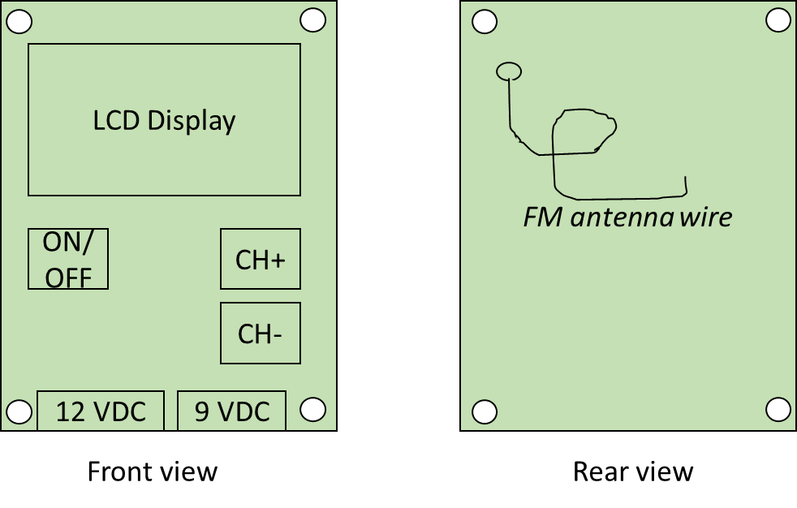

FOR THE FUNCTIONING OF THE 555 CLOCK SIGNAL GENERATOR, READ HERE

<https://howtomechatronics.com/how-it-works/electronics/555-timer-ic-working-principle-block-diagram-circuit-schematics/>

and look also at the calculations done on the notebook (you should copy them on latex). You can also look at the ppt presentation.